Name: Abrha Gebreslassie, Berhe

Subject: Lab Assignment - 3

**Problem – 1 – Explanation**

The reason for the equals () method to show different results when tested differently is because the ***Liskov Substitution Principle (*LSP*)*** is violated. Even though the “PersonWithJob” IS-A “Person”, its instance cannot substitute instance of the class “Person” because it has an instance variable “salary” while the “Person” class has not. The equals () method in the “PersonWithJob” class expects the “Person” class to have equal salary to return “true” result.

**Problem – 3 – UML Diagram**

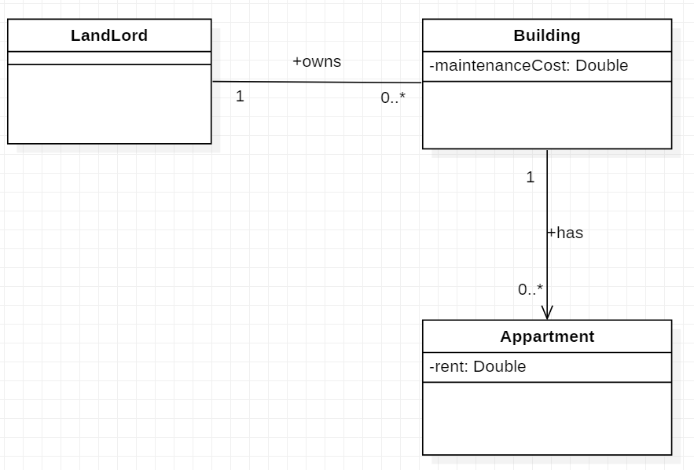

**Problem – 3**

1. **Explanation**

Let's check the two criteria for inheritance:

1) IS-A relationship

* A Circle is a Cylinder: False

2) LSP - the substitution principle.

* We can use a Circle object in place of Cylinder object: False.

In addition, Circle inherits all attributes and behaviors of Cylinder, which are unnecessary for a circle object. As per the UML diagram, the Circle constructor takes only one double parameter.

So We can pass 0.0 as the second parameter to avoid compiler error, which is again unnecessary.

Therefore, it does not make sense to use inheritance here.

1. **UML-Diagram**

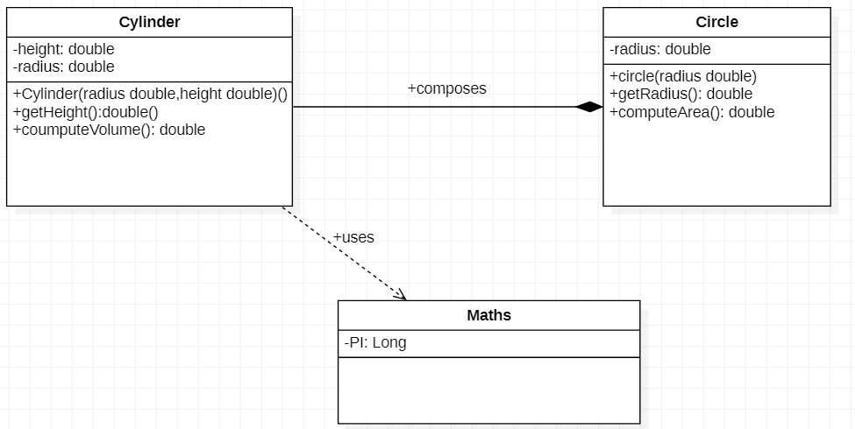

**Problem –4 – UML Diagram**

